Technical Guide for the UCAS calculator version 1.0

Made by Savelij Borovskij

Content

Development Environment 2

Target Platform 2

User Requirements 2

Design of the programming solution (screen layout) 2

Working program 4

Code 6

Main menu 6

Calculation screen 6

Settings menu 8

Description menu 9

Error 1 screen 9

Error 2 screen 9

Work in progress (WIP) screen 9

Maintenance 10

## Development Environment

For the development environment I chose Visual Basic .NET programming language. As an environment I used console programming, which is procedural programming.

## Target Platform

The target platform for the UCAS Calculator program is Windows operating system.

## User Requirements

I am asked to develop a small procedural program that shows the key features of EDP programming. It is called UCAS Calculator. The program allows user to first select a specific BTEC level 3 qualification, it then takes number of passes, merits and distinctions as inputs; Once the required inputs are provided the program allows user to produce an overall grade and the corresponding UCAS points as the outputs.

Additional features:

1) On-screen help

2) Background colour

3) Font size

## Design of the programming solution (screen layout)

1) main menu screen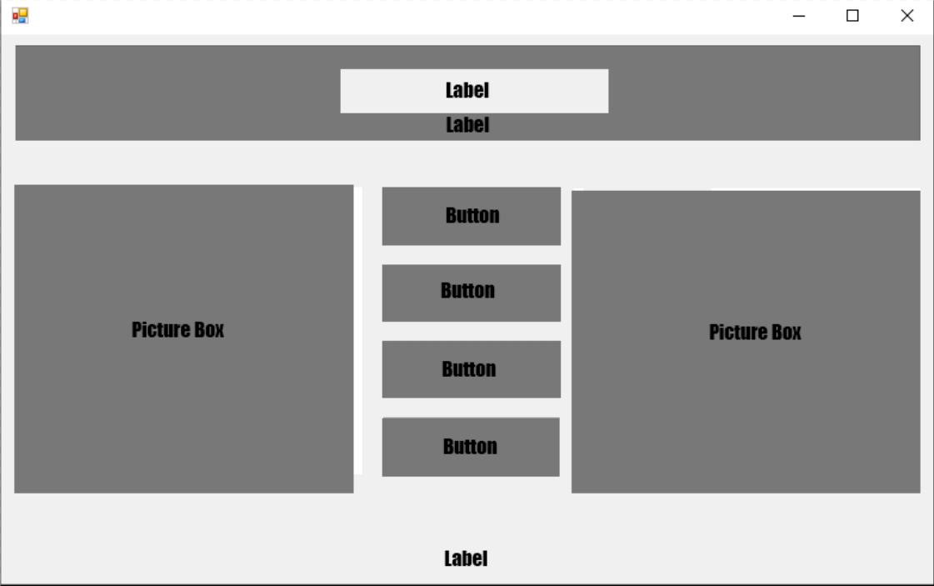

2)calculations screen

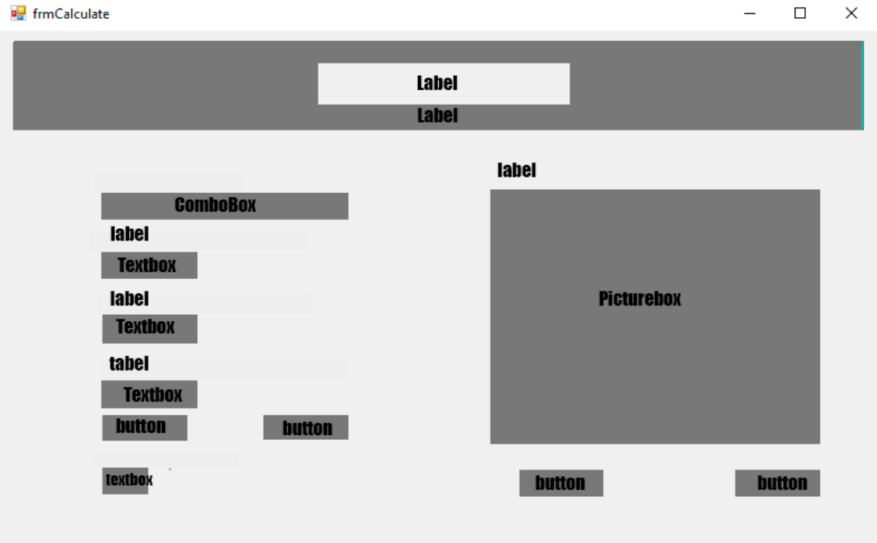

3)settings screen

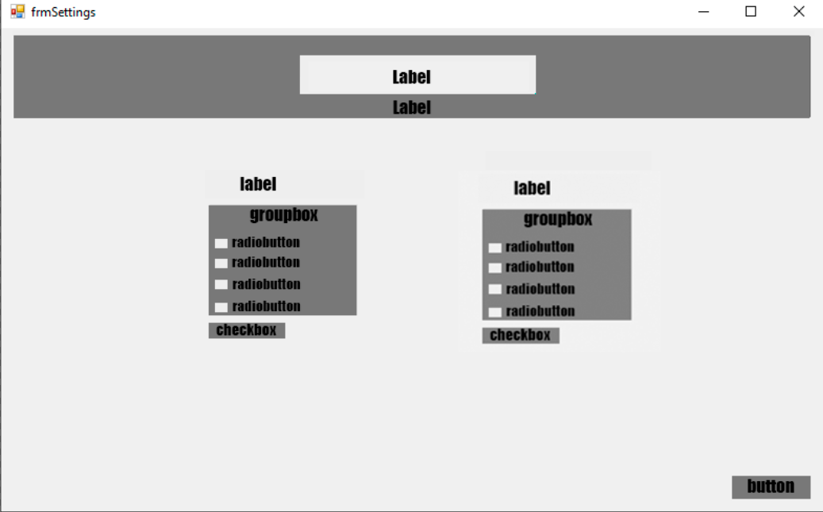

## Working program

Once I run my program there is a title screen with name of the program at the top. To the right and to the left there are 2 picture boxes. In the middle there are 4 options. You can use exit button to finish the program. [1]

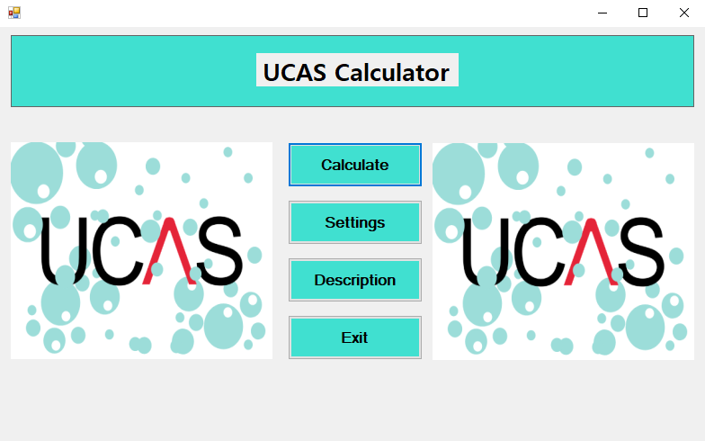[1]

If you choose ‘Calculate’ it will lead you to the next screen. On that screen you can select qualification from combo box, then type what grades you have in the corresponding text boxes and press calculate button to get your TARIF points or Clear button to erase all the input.[2]

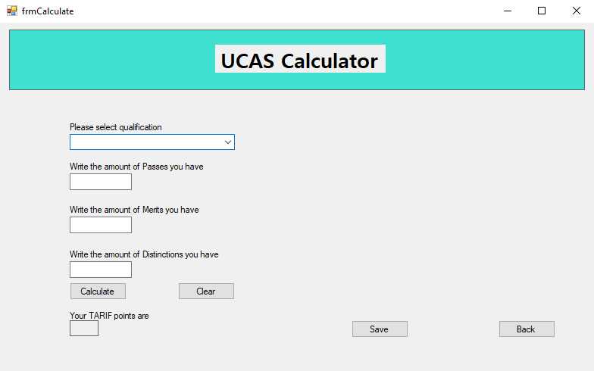[2]

Also, when you choose the qualification, the picture box with the table appears so you can see what grade you get. [3]

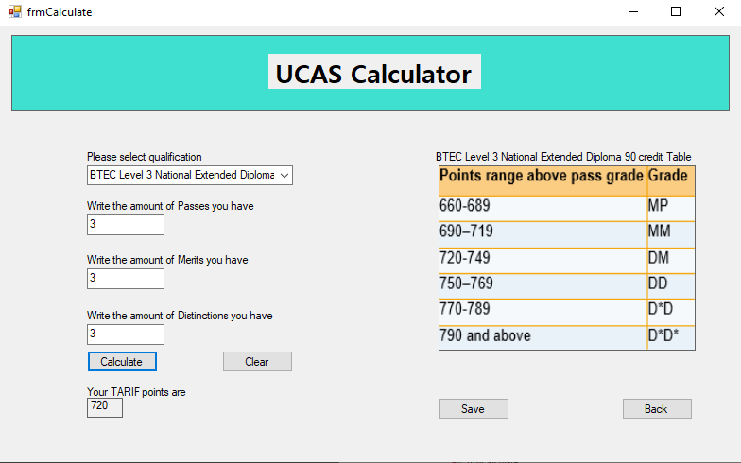[3]

If you input wrong number of grades the error message will appear. [4]

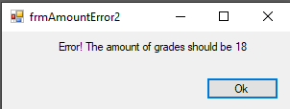[4]

If you select settings from main menu, you will proceed to another screen. Here you can change the colour of the background as well as font type.[5]

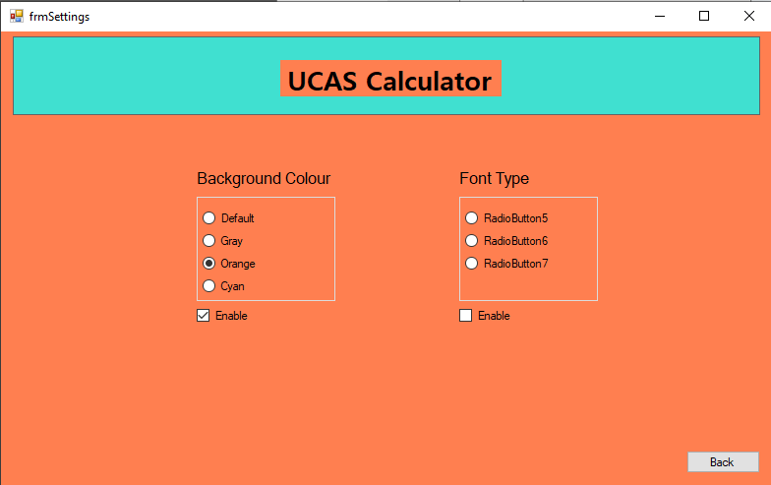[5]

If you select description in the main menu, you will see the basic description of the program. Here you can find information about UCAS calculator, how does the program work and credits. [6]

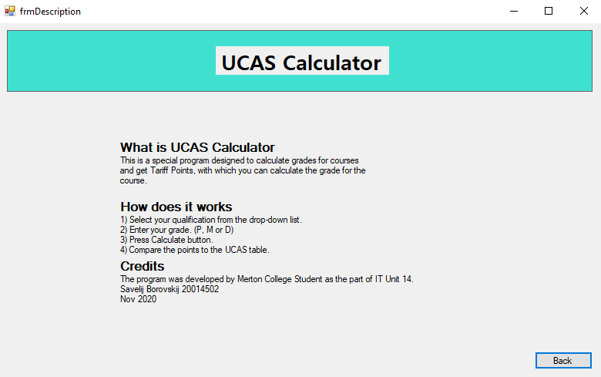[6]

## Code

### Main menu

Public Class frmMain

Private Sub Button4_Click(sender As Object, e As EventArgs) Handles benExit.Click

'Close the application

Me.Close()

End Sub

Private Sub Button1_Click(sender As Object, e As EventArgs) Handles btnCalculate.Click

'Hide current screen and display another

frmCalculate.Show()

Me.Hide()

End Sub

Private Sub btnSettings_Click(sender As Object, e As EventArgs) Handles btnSettings.Click

'Hide current screen and display another

frmSettings.Show()

Me.Hide()

End Sub

Private Sub btnHelp_Click(sender As Object, e As EventArgs) Handles btnHelp.Click

'Hide current screen and display another

frmDescription.Show()

Me.Hide()

End Sub

End Class

### Calculation screen

Public Class frmCalculate

Dim P As Decimal 'declaring new variables as decimal

Dim M As Decimal

Dim D As Decimal

Dim Result As Decimal

Private Sub frmCalculate_Load(sender As Object, e As EventArgs) Handles MyBase.Load

pbx90Table.Hide()

lbl90Table.Hide() 'Hiding some labels and picture boxes once this form is launched

pbx180Table.Hide()

lbl180Table.Hide()

End Sub

Private Sub TextBox1_TextChanged(sender As Object, e As EventArgs) Handles txtP.TextChanged

'Declaring that every value that will be written in txtP textbox will be P value

P = Val(txtP.Text)

End Sub

Private Sub txtM_TextChanged(sender As Object, e As EventArgs) Handles txtM.TextChanged

'Declaring that every value that will be written in txtM textbox will be M value

M = Val(txtM.Text)

End Sub

Private Sub txtD_TextChanged(sender As Object, e As EventArgs) Handles txtD.TextChanged

'Declaring that every value that will be written in txtD textbox will be D value

D = Val(txtD.Text)

End Sub

Private Sub btnCal_Click(sender As Object, e As EventArgs) Handles btnCal.Click

If cmbQual.SelectedIndex = 0 Then

If P + M + D <> 9 Then

Me.Hide()

frmAmountError.Show()

txtP.Clear()

txtM.Clear()

txtD.Clear()

End If

ElseIf cmbQual.SelectedIndex = 1 Then

If P + M + D <> 18 Then

Me.Hide()

frmAmountError2.Show()

txtP.Clear()

txtM.Clear()

txtD.Clear()

End If

End If

'Coding a formula for Result calculations

Result = P * 70 + M * 80 + D * 90

lblResult.Text = Result 'Displaying the result in the specific label

End Sub

Private Sub btnClear_Click(sender As Object, e As EventArgs) Handles btnClear.Click

'setting all values to 0 and clearing variables

txtP.Clear()

txtM.Clear()

txtD.Clear()

lblResult.Text = 0

End Sub

Private Sub btnClose_Click(sender As Object, e As EventArgs) Handles btnBack.Click

'Hiding current window and showing main menu

Me.Hide()

frmMain.Show()

End Sub

Private Sub PictureBox1_Click(sender As Object, e As EventArgs) Handles pbx90Table.Click

End Sub

Private Sub ComboBox1_SelectedIndexChanged(sender As Object, e As EventArgs) Handles cmbQual.SelectedIndexChanged

If cmbQual.SelectedIndex = 0 Then 'when user select 1st item from combo box label and table appears

pbx90Table.Show()

lbl90Table.Show() 'Hiding other label and table if other is selected

pbx180Table.Hide()

lbl180Table.Hide()

ElseIf cmbQual.SelectedIndex = 1 Then 'when user select 2nd item from combo box label and table appears

pbx180Table.Show()

lbl180Table.Show()

pbx90Table.Hide() 'Hiding other label and table if other is selected

lbl90Table.Hide()

End If

End Sub

Private Sub btnSave_Click(sender As Object, e As EventArgs) Handles btnSave.Click

frmWIP.Show()

End Sub

End Class

### Settings menu

Public Class frmSettings

Private Sub ckbFont_CheckedChanged(sender As Object, e As EventArgs) Handles ckbFont.CheckedChanged

End Sub

Private Sub btnBack_Click(sender As Object, e As EventArgs) Handles btnBack.Click

'Hide current screen and display another

Me.Hide()

frmMain.Show()

End Sub

Private Sub ckbBgdC_CheckedChanged(sender As Object, e As EventArgs) Handles ckbBgdC.CheckedChanged

'if checked then eneble the colour change group

'if unchecked then disable the colour change group

If ckbBgdC.Checked Then

grpBgdC.Enabled = True

Else

grpBgdC.Enabled = False

End If

End Sub

Private Sub rdbDefault_CheckedChanged(sender As Object, e As EventArgs) Handles rdbDefault.CheckedChanged

'Changing background colour for all screens

Me.BackColor = DefaultBackColor

frmCalculate.BackColor = DefaultBackColor

frmMain.BackColor = DefaultBackColor

frmAmountError.BackColor = DefaultBackColor

frmAmountError2.BackColor = DefaultBackColor

End Sub

Private Sub rdbGrey_CheckedChanged(sender As Object, e As EventArgs) Handles rdbGray.CheckedChanged

'Changing background colour for all screens

Me.BackColor = Color.Gray

frmCalculate.BackColor = Color.Gray

frmAmountError.BackColor = Color.Gray

frmAmountError2.BackColor = Color.Gray

frmMain.BackColor = Color.Gray

End Sub

Private Sub rdbBlue_CheckedChanged(sender As Object, e As EventArgs) Handles rdbOrange.CheckedChanged

'Changing background colour for all screens

Me.BackColor = Color.Coral

frmCalculate.BackColor = Color.Coral

frmAmountError.BackColor = Color.Coral

frmAmountError2.BackColor = Color.Coral

frmMain.BackColor = Color.Coral

End Sub

Private Sub rdbYellow_CheckedChanged(sender As Object, e As EventArgs) Handles rdbCyan.CheckedChanged

'Changing background colour for all screens

Me.BackColor = Color.Cyan

frmCalculate.BackColor = Color.Cyan

frmAmountError.BackColor = Color.Cyan

frmAmountError2.BackColor = Color.Cyan

frmMain.BackColor = Color.Cyan

End Sub

End Class

### Description menu

Public Class frmDescription

Private Sub Back_Click(sender As Object, e As EventArgs) Handles Back.Click

'Hide current screen and display another

Me.Hide()

frmMain.Show()

End Sub

End Class

### Error 1 screen

Public Class frmAmountError

Private Sub btnOk_Click(sender As Object, e As EventArgs) Handles btnOk.Click

'Hide current screen and display another

Me.Hide()

frmCalculate.Show()

End Sub

End Class

### Error 2 screen

Public Class frmAmountError2

Private Sub btnOk_Click(sender As Object, e As EventArgs) Handles btnOk.Click

'Hide current screen and display another

Me.Hide()

frmCalculate.Show()

End Sub

End Class

### Work in progress (WIP) screen

Public Class frmWIP

Private Sub btnClose_Click(sender As Object, e As EventArgs) Handles btnClose.Click

Me.Close()

End Sub

End Class

## Maintenance

To service my program, I will need to conduct tests and debugs every month. To do this, feedback from users will be collected and errors will be checked and resolved. Also in the future, it is planned to improve the graphic design by supplementing the interface and adding various frames, lines, etc.